

**PARENTS** & **PLAYERS**:

**Important info regarding uniform check out/return**

Each gear item is checked out to each player through the South Eugene High school resource tracker FOLLETT DESTINY. This is the same system students use to check out books at school.

A completed South Eugene soccer uniform checkout form is required prior to getting a uniform

Each player is responsible for returning the *exact* same items checked out to them in good condition. Training shirts and socks are for players to keep. DO NOT return these items.

Privilege of representing AXE SOCCER includes off-field and off-season. Maintain the high standard of conduct befitting your team when wearing your gear.

**FAQ**

**WHEN DO I CHECK OUT/TURN IN MY UNIFORM?**

Your team manager and coach will schedule your team’s uniform check-out/turn-in**.**

In school computer system, **final soccer uniform due date** is 11/17/2022. Missing and late items will be processed by South Eugene High School per school policy. This includes fines and billing for replacement cost.

**HOW DO I TURN IN MY UNIFORM?**

Player (or their designee) must presentgear directly **to the person designated by their team** and be scanned back into the system in order to be considered returned**. Do not present your uniform to coach, school office, athletic director. etc**.

**I CAN’T ATTEND/MISSED MY TEAM’S UNIFORM DISTRIBUTION/TURN IN. WHAT SHOULD I DO?**

Contact your team manager for instructions, or designate another player or parent to return your uniform for you. **NOTE**: if you choose to send your uniform back with another player, YOU are still responsible if the uniform doesn’t get turned in!

**HOW DO I CHANGE UNIFORMS DURING THE SEASON?**

Contact your team manager to assist you. They will help you turn in and check out a new one. Do not borrow or trade uniforms without notifying your manager. This is the situation that causes hard feelings, lost uniforms and replacement fees.

**HOW DO I KNOW WHAT I CHECKED OUT?**

Players can view their Follett destiny account. This includes a description, barcode number of each of your items, replacement cost, date checked out, due date.

**HOW DO SEE MY FOLLETT DESTINY ACCOUNT?**

Library staff at school is available to help any student with this. Want to do this at home? See instructions below.

**I HAVE A UNIFORM ITEM BUT I DON’T KNOW WHOSE IT IS. HELP!**

Your team manager can easily determine who the item belongs to. Share the barcode on the mystery item (in real life, by sending a photo of the barcode, or by telling them the number).

**HOW DO I KNOW IF I HAVE MY OWN UNIFORM? I THINK MINE MAY HAVE GOTTEN MIXED UP WITH SOMEONE ELSE’S.**

Check the barcode on the item and make sure it matches the one in your student account. You are responsible for sorting this out and returning your own gear. Let your team manager know so that they can help. On items that look alike, duct tape your name inside!

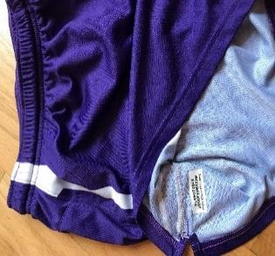 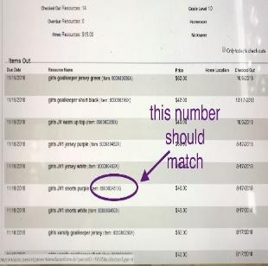

**I TURNED IN A UNIFORM THAT WAS NOT THE ONE I CHECKED OUT. DOES THAT COUNT?**

No. You must return what was originally checked out to you. Contact your team manager for assistance.

**I LOST/SOMETHING HAPPENED WITH MY UNIFORM. WHAT SHOULD I DO?**

Let your team manager know ASAP so that they can help you.

**INSTRUCTIONS FOR ACCESSING YOUR SCHOOL ACCOUNT:**

Start at South Eugene high school website <https://sehs.4j.lane.edu/>

Use your student login name/number, student password.

